DevOps

AWS Services Overview 2

AWS Overview and Shared Responsibility Model 2

Elasticity 3

High Availability (HA) 4

AWS Global Infrastructure - Regions and Availability Zones (AZs) 6

EC2, Load Balancer, Elastic Beanstalk & LightSail 8

AWS Lambda for EC2 Automation 10

S3 (Simple Storage Service) 12

Elastic Block Storage (EBS) 14

AWS Storage Services 16

Database Services 18

AWS ElastiCache 19

Networking Services 21

CloudFront 22

AWS Monitoring, Security, and Support Overview 24

# AWS Services Overview

## AWS Overview and Shared Responsibility Model

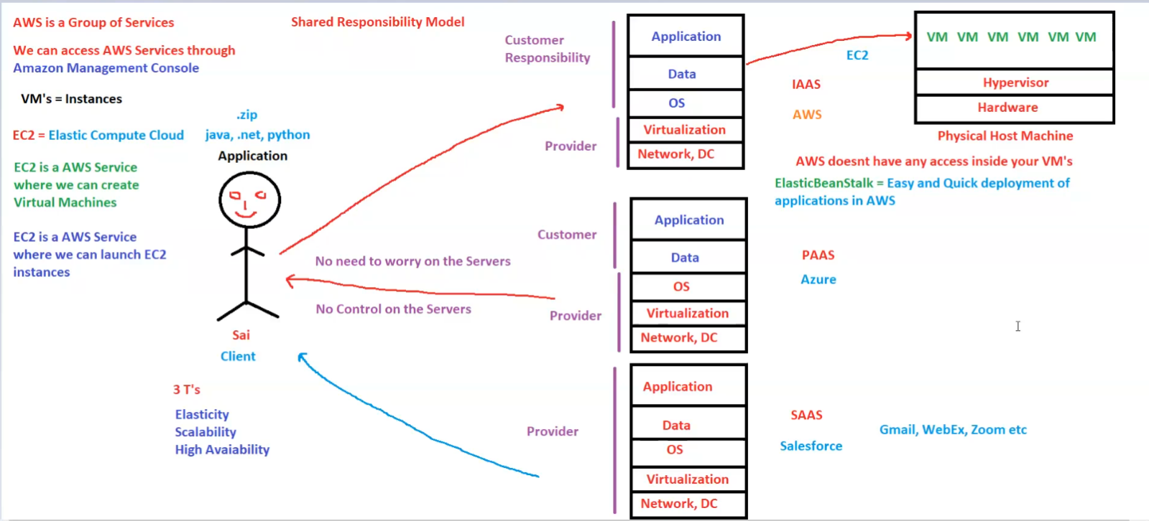

Here are the notes based on the image:

**AWS Overview and Shared Responsibility Model**

**1. AWS Basics**

* **AWS (Amazon Web Services)** is a group of cloud services.
* We can access AWS services via the **Amazon Management Console**.
* **VMs (Virtual Machines) = Instances** in AWS.

**2. EC2 (Elastic Compute Cloud)**

* **EC2** is an AWS service that allows users to create and launch virtual machines.
* **EC2 falls under the Infrastructure as a Service (IAAS) model**.
* AWS does not have access inside your virtual machines.

**3. Shared Responsibility Model**

* **Customer Responsibility**: Application and Data management.
* **Provider Responsibility**: Network, Data Center, and Virtualization.
* **Shared Responsibility**:
  + Customers do not need to worry about servers.
  + Customers have no control over the physical servers.

**4. Cloud Service Models**

1. **IAAS (Infrastructure as a Service)**
   * Example: **AWS EC2**
   * Customers manage applications, data, and OS, while AWS handles virtualization and infrastructure.
2. **PAAS (Platform as a Service)**
   * Example: **Azure, AWS Elastic Beanstalk**
   * Provides an environment for application development and deployment.
3. **SAAS (Software as a Service)**
   * Examples: **Salesforce, Gmail, WebEx, Zoom**
   * Fully managed applications accessible via the internet.

**5. Benefits of AWS (The 3 T’s)**

* **Elasticity**
* **Scalability**
* **High Availability**

**6. AWS Infrastructure**

* AWS physical host machines run multiple virtual machines (VMs) using a **Hypervisor**.
* **Elastic Beanstalk** is an AWS service for easy and quick application deployment.

## Elasticity

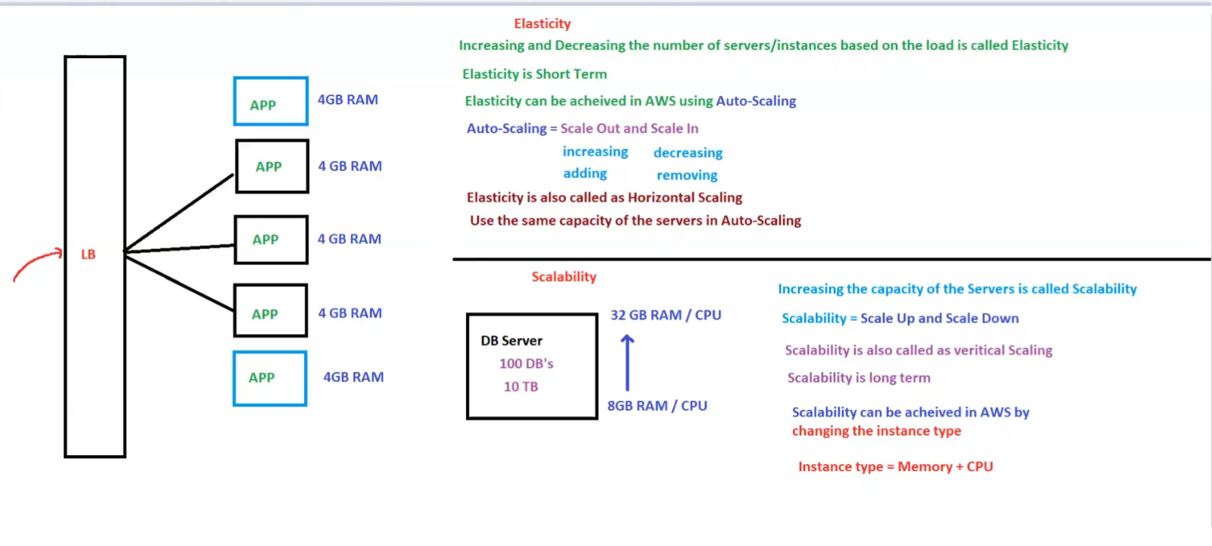

**Elasticity**

* **Definition**: Increasing and decreasing the number of servers/instances based on the load is called **Elasticity**.
* **Characteristics**:
  + Elasticity is **short-term**.
  + Achieved in **AWS using Auto-Scaling**.
  + **Auto-Scaling** involves:
    - **Scale Out** (increasing/adding instances)
    - **Scale In** (decreasing/removing instances)
  + Also known as **Horizontal Scaling**.
  + Uses **same capacity servers** in Auto-Scaling.

**Scalability**

* **Definition**: Increasing the **capacity** of servers is called **Scalability**.
* **Characteristics**:
  + Scalability = **Scale Up and Scale Down**.
  + Also called **Vertical Scaling**.
  + Scalability is **long-term**.
  + Achieved in **AWS by changing the instance type**.
  + **Instance Type** = **Memory + CPU**.

**Key Differences**

|  |  |  |
| --- | --- | --- |
| **Feature** | **Elasticity (Horizontal Scaling)** | **Scalability (Vertical Scaling)** |
| **Definition** | Adjusting the number of instances | Increasing server capacity |
| **Timeframe** | Short-term | Long-term |
| **AWS Feature** | Auto-Scaling | Changing Instance Type |
| **Process** | Scale In/Out (adding/removing instances) | Scale Up/Down (increasing/decreasing resources) |
| **Capacity** | Uses same capacity servers | Increases capacity of the same server |

## High Availability (HA)

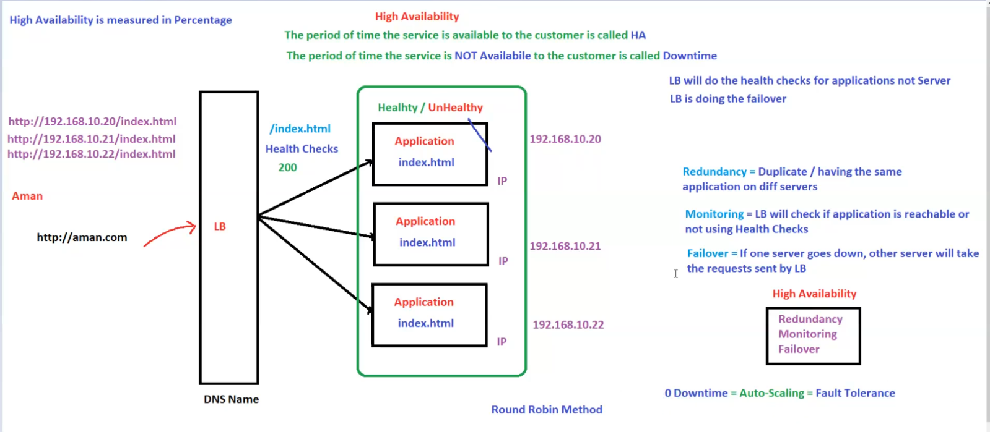

**High Availability (HA)**

* **Definition**: The period of time the service is **available** to the customer is called **High Availability (HA)**.
* **Downtime**: The period of time the service is **not available** to the customer is called **Downtime**.
* **HA is measured in percentage**.

**Key Components of High Availability**

1. **Redundancy**:
   * **Definition**: Having duplicate instances of the same application on different servers.
2. **Monitoring**:
   * **Definition**: Load Balancer (LB) checks if the application is reachable using **Health Checks**.
   * Health Check: Verifies the availability of **index.html** and expects a **200 status**.
3. **Failover**:
   * **Definition**: If one server goes down, other servers take over the requests handled by the Load Balancer.

**Load Balancer (LB)**

* **Handles incoming traffic and distributes it across multiple servers**.
* **Performs Health Checks** for applications (not servers).
* **Performs failover** to redirect traffic if a server goes down.
* **Uses Round Robin Method** for load distribution.

**Ensuring 0 Downtime**

* **Auto-Scaling = Fault Tolerance**
* **Combining**:
  + **Redundancy**
  + **Monitoring**
  + **Failover**  
    Leads to **High Availability**.

**Example Setup**

* **DNS Name:** http://aman.com
* **Backend servers with IPs**:
  + 192.168.10.20
  + 192.168.10.21
  + 192.168.10.22
* Each server hosts index.html, and the Load Balancer distributes traffic among them.

## AWS Global Infrastructure - Regions and Availability Zones (AZs)

**AWS Global Infrastructure - Regions and Availability Zones (AZs)**

**1. AWS Global Infrastructure Overview**

* **Region**: A physical location where AWS has infrastructure (e.g., Mumbai).
* **Availability Zone (AZ)**: A **data center** within a region.
* **A Region has multiple AZs**, and each AZ is a group of **data centers** (DCs).
* **Servers (EC2 Instances)** are placed within **AZs**.

**2. AWS Region and Availability Zones**

* **Example**: AWS Region **Mumbai** (ap-south-1) has **three AZs**:
  + **ap-south-1a**
  + **ap-south-1b**
  + **ap-south-1c**
* **AZs are managed by AWS** and are **interconnected via a network**.
* **Best Practice**: Distribute instances across **multiple AZs** for high availability.

**3. Communication Between AZs & Regions**

* **AZs within a region** can communicate with each other **by default**.
* **Regions do NOT communicate by default**, but it can be enabled if required.
* **Low Latency (1 sec) is good**, while **high latency (5 sec) is bad**.

**4. Load Balancing & Traffic Distribution**

* **Load Balancer (LB)**:
  + Distributes traffic across **multiple EC2 instances** in different **AZs**.
  + **LB is specific to a region**, not an AZ.
* **Instances across AZs** can share data if required.

**5. High Availability & Fault Tolerance**

* **Very low chance** that an entire **AZ goes down**.
* **Distributing instances across AZs** ensures **fault tolerance**.
* **If one AZ fails, others continue running**.

**6. Example Mapping (Mumbai Region)**

* **ap-south-1a**: Dadar, Thane, Bandra
* **ap-south-1b**: Airoli, Kalyan, Kurla
* **ap-south-1c**: CST, Juhu, Panvel

**7. Summary**

✅ **Region** = Group of AZs.  
✅ **AZ** = Group of Data Centers (DCs).  
✅ **AZs within a region can communicate**.  
✅ **Regions do NOT communicate by default**.  
✅ **Load Balancers distribute traffic across AZs**.  
✅ **Best practice**: Use multiple AZs for **high availability & redundancy**.

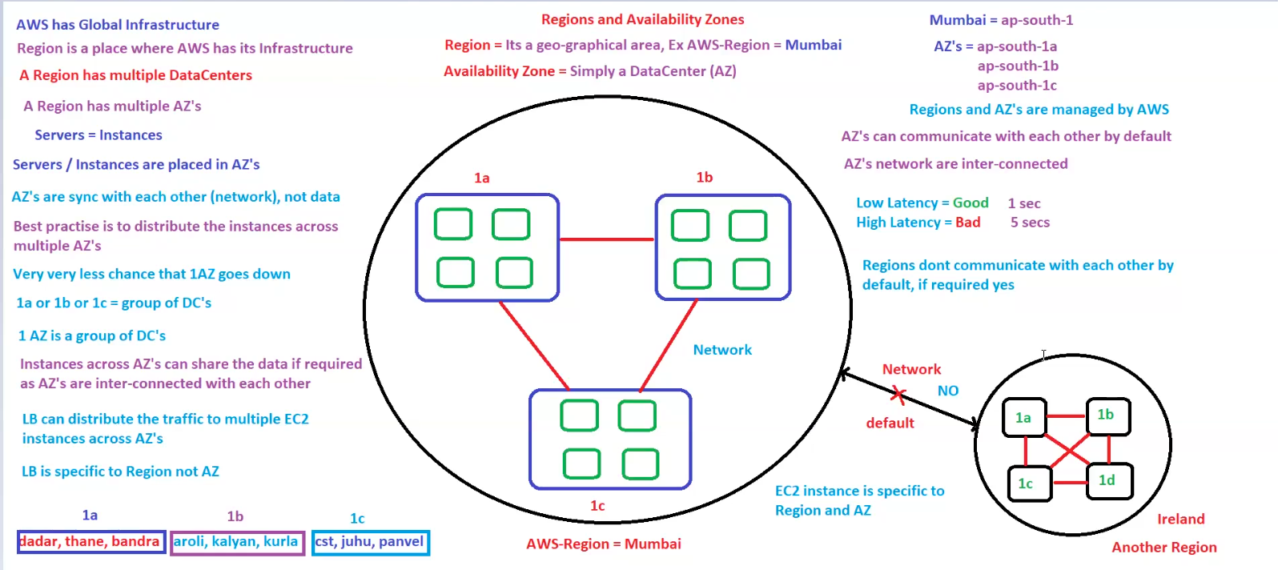

## EC2, Load Balancer, Elastic Beanstalk & LightSail

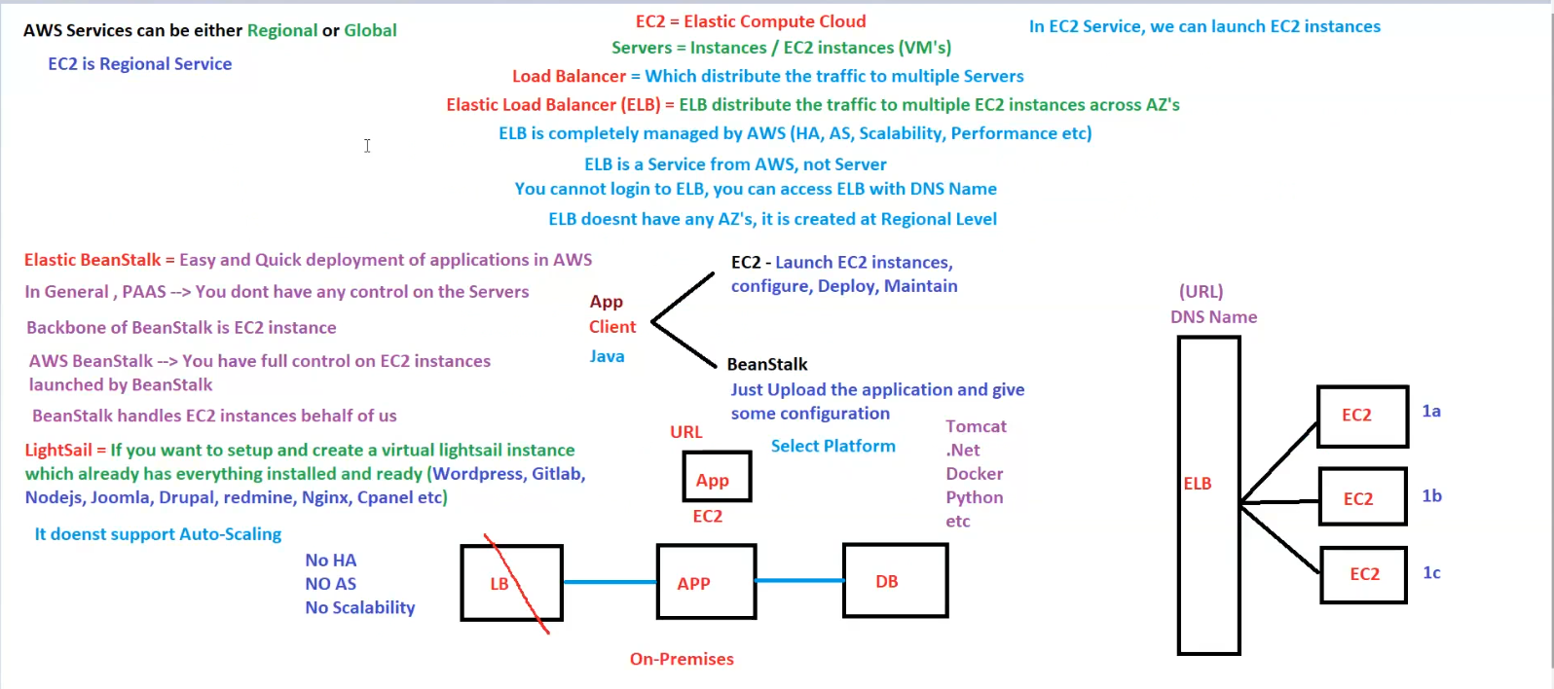

**1. AWS Services - Regional vs Global**

* **AWS Services can be either Regional or Global.**
* **EC2 (Elastic Compute Cloud) is a Regional Service**
  + It means EC2 instances exist within a **specific AWS region**.
  + EC2 instances are virtual machines (VMs) in the cloud.

**2. EC2 Instances**

* **EC2 = Elastic Compute Cloud** → Allows launching virtual servers (instances).
* **Servers = Instances (EC2 VMs).**
* EC2 instances need to be **configured, deployed, and maintained manually**.

**3. Load Balancer (LB)**

* **Distributes incoming traffic** across multiple EC2 instances.
* **Elastic Load Balancer (ELB)**
  + **ELB distributes traffic across EC2 instances in different AZs.**
  + **Managed by AWS** (High Availability, Auto Scaling, Performance Optimization).
  + **Created at the Regional Level**, not tied to a specific AZ.
  + **Cannot log in to ELB**, only access it via DNS name.

**4. Elastic Beanstalk (PaaS)**

* **Simplifies application deployment** on AWS.
* **Fully managed service**, handling EC2 instances, Load Balancing, and Auto Scaling.
* **Key Features:**
  + Uses **EC2 instances as the backbone**.
  + You have **full control over EC2 instances**.
  + Just **upload your application** and provide configuration.
  + Supports **multiple platforms** like **Tomcat, .Net, Docker, Python, etc.**

**5. AWS LightSail (Simplified VM Hosting)**

* **Pre-configured cloud service** for hosting applications quickly.
* Supports **WordPress, GitLab, Node.js, Joomla, Drupal, Nginx, Cpanel, etc.**
* **Limitations**:
  + ❌ **No Auto-Scaling**.
  + ❌ **No High Availability (HA)**.
  + ❌ **No Scalability** (Cannot dynamically scale like EC2 with ELB).

**6. EC2 Deployment Options**

**A. EC2 with ELB (Recommended)**

✅ EC2 instances are deployed across **multiple AZs**.  
✅ **ELB distributes traffic** to maintain high availability.  
✅ **Auto Scaling** ensures instances scale up/down as needed.

**B. EC2 with Beanstalk**

✅ Easy deployment and management.  
✅ **AWS manages scaling & load balancing**.  
✅ **Ideal for developers** who don’t want to manage infrastructure.

**C. EC2 Without Load Balancer (Not Recommended)**

❌ Single EC2 instance without redundancy.  
❌ **No auto-scaling** = No ability to handle high traffic.  
❌ **If the instance fails, the application is down.**

**7. Summary**

| **AWS Service** | **Use Case** | **Key Features** |
| --- | --- | --- |
| **EC2** | General-purpose compute | Manual setup, requires maintenance |
| **ELB** | Load balancing traffic | Auto-distributes requests across EC2 instances |
| **Elastic Beanstalk** | Easy application deployment | PaaS, fully managed, supports multiple platforms |
| **LightSail** | Quick app hosting | Simple VM setup, no scaling, no HA |

✅ **Use EC2 + ELB for scalable and fault-tolerant architecture.**  
✅ **Use Beanstalk for easy deployment with AWS-managed scaling.**  
✅ **Use LightSail for simple, pre-configured environments without scaling needs.**

## AWS Lambda for EC2 Automation

**1. AWS Lambda Overview**

* **Lambda is a Serverless service** → No need to manage servers.
* You can **run code** without provisioning infrastructure.
* Supports **multiple languages** like **Java, Python, .NET, Ruby, etc.**
* Lambda can be **triggered by events** (e.g., EC2 state changes, scheduled tasks, etc.).

**2. Automating EC2 with Lambda**

* **Lambda can perform EC2 operations**:  
  ✅ **Launch**  
  ✅ **Stop**  
  ✅ **Start**  
  ✅ **Reboot**  
  ✅ **Terminate/Delete**
* **Lambda is triggered based on:**
  + **EventBridge Rules** (For Scheduled Events).
  + **Launch Events** (For EC2 instance events).

**3. Event-Based EC2 Management Using Lambda**

**A. Scheduled Stop & Start of EC2 Instances**

* **9 PM → STOP EC2 Instances**
  + **EventBridge Rule triggers STOPFn Lambda function**.
  + Lambda stops all EC2 instances.
* **6 AM → START EC2 Instances**
  + **EventBridge Rule triggers StartFn Lambda function**.
  + Lambda starts all EC2 instances.

**B. EC2 Termination Using Lambda**

* **Lambda can terminate EC2 instances using Python Code (TerminateFn).**
* This can be invoked manually or automatically via **EventBridge**.
* Example Use Case: **Auto-terminate idle EC2 instances** to reduce costs.

**4. AWS Services Involved**

| **Service** | **Purpose** |
| --- | --- |
| **Lambda** | Runs Python code to start/stop EC2 instances. |
| **EventBridge** | Schedules events (9 PM Stop, 6 AM Start). |
| **EC2** | Instances managed via Lambda automation. |

**5. Summary**

✅ **AWS Lambda is used for automating EC2 instance operations.**  
✅ **EventBridge rules** can **trigger Lambda functions** to start/stop EC2 instances **on schedule**.  
✅ **Lambda functions** can be used for **launching, stopping, and terminating EC2 instances automatically**.  
✅ **Serverless automation** reduces manual effort & optimizes cloud costs.

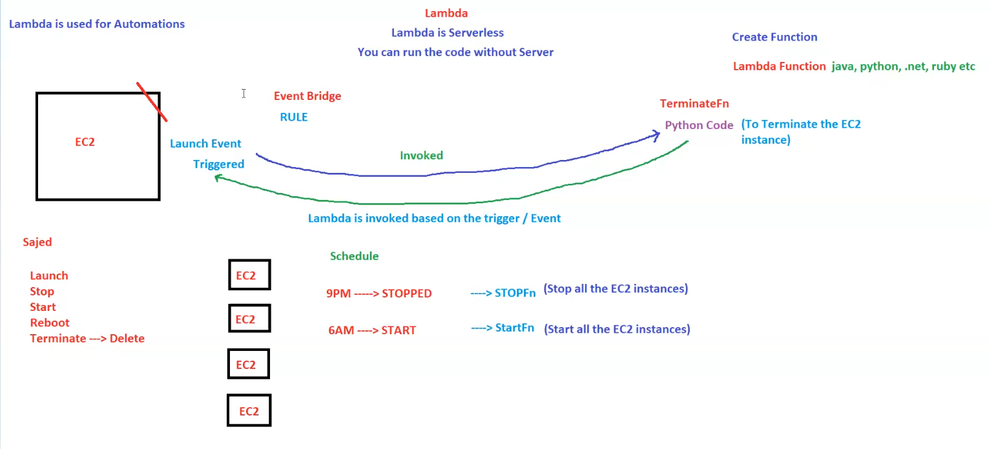

## S3 (Simple Storage Service)

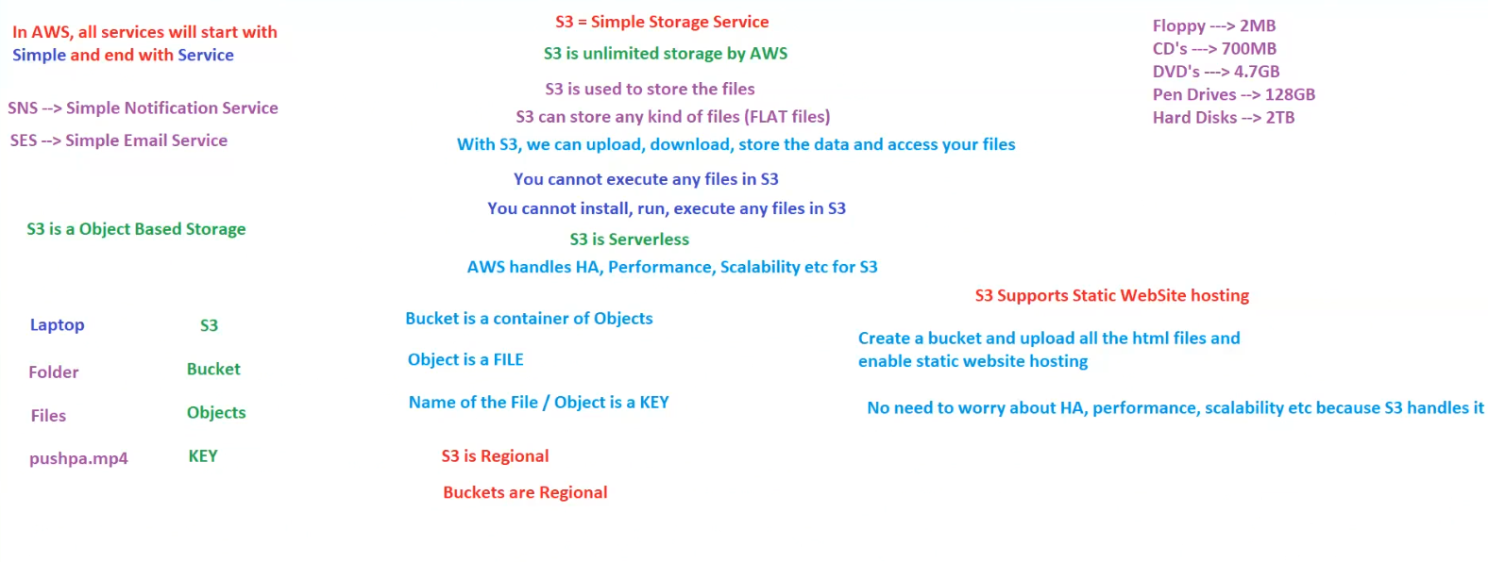

**1. What is AWS S3?**

* **S3 = Simple Storage Service**.
* **S3 provides unlimited storage** managed by AWS.
* **S3 is used for storing files** (object-based storage).
* **Supports any type of file** (flat files like images, videos, documents, backups, etc.).
* **S3 is Serverless** – No need to manage infrastructure.
* **AWS handles High Availability (HA), Performance, and Scalability**.

**2. How S3 Works? (Folder & File Concept)**

| **Local System (Laptop)** | **S3 Equivalent** |
| --- | --- |
| **Laptop** | **S3** |
| **Folder** | **Bucket** |
| **Files** | **Objects** |
| **File Name** | **Key** |

* **Bucket**: A container for storing objects (files).
* **Object**: A stored file.
* **Key**: The unique name assigned to an object (file name).

**3. S3 Storage Features & Limitations**

✅ **Can upload, download, and store files**.  
❌ **Cannot execute, install, or run any files directly in S3**.  
✅ **Supports Static Website Hosting** (for hosting HTML files).  
✅ **S3 is Regional** → Buckets exist within a specific AWS region.  
❌ **Buckets are also Regional** (Cannot access from different regions unless configured).

**4. S3 Static Website Hosting**

* **S3 supports static website hosting**.
* **Steps to host a website on S3**:
  1. **Create a Bucket**.
  2. **Upload HTML files**.
  3. **Enable static website hosting**.
  4. **S3 will manage HA, Performance, and Scalability**.

✅ No need for additional infrastructure like EC2.

**5. Comparison of Traditional Storage vs S3**

| **Storage Type** | **Capacity** |
| --- | --- |
| **Floppy Disk** | 2MB |
| **CD** | 700MB |
| **DVD** | 4.7GB |
| **Pen Drive** | 128GB |
| **Hard Disk** | 2TB |
| **S3** | **Unlimited** ✅ |

**6. Summary**

| **Feature** | **Details** |
| --- | --- |
| **Type** | Object Storage |
| **Storage Limit** | Unlimited ✅ |
| **Execution** | Cannot execute files ❌ |
| **Static Website Hosting** | Supported ✅ |
| **Region** | S3 is Regional ✅ |
| **Bucket Region** | Buckets are Regional ✅ |

✅ **Use S3 for file storage, backups, and hosting static websites**.  
✅ **For shared storage across multiple regions, enable S3 Cross-Region Replication**.

## Elastic Block Storage (EBS)

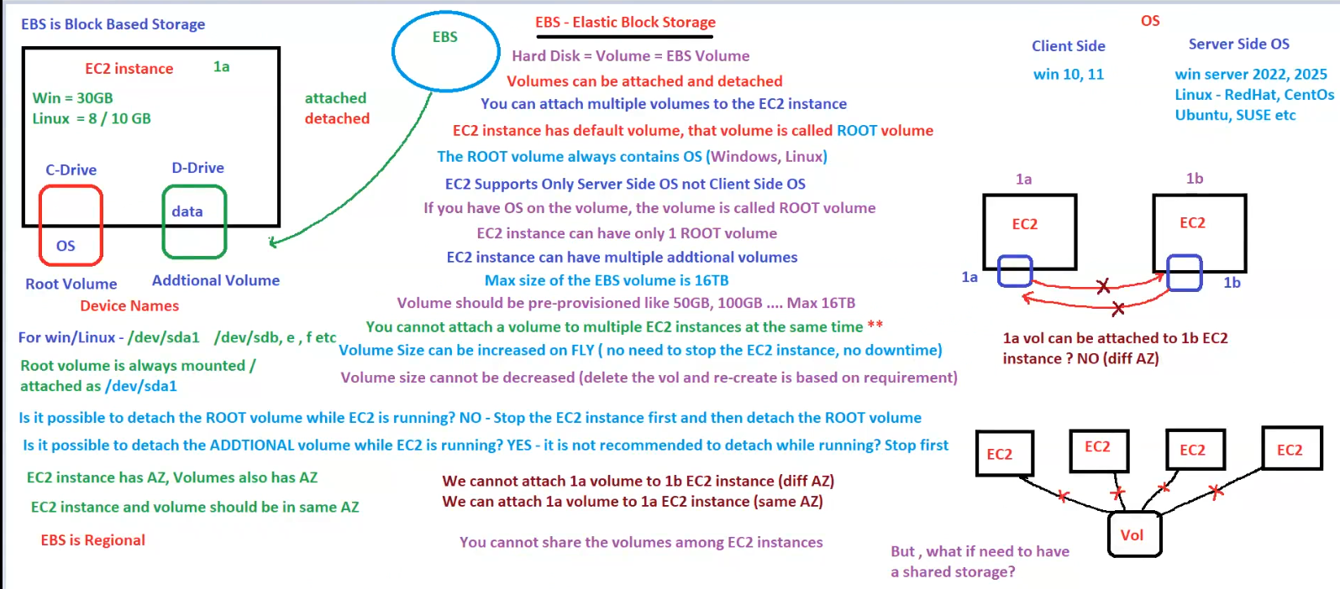

**1. What is EBS (Elastic Block Storage)?**

* **EBS is a block-based storage system** for EC2 instances.
* Acts like a **hard disk (volume)** that can be **attached and detached** from EC2 instances.
* **EBS is Regional** → Volumes exist within a specific AWS region.
* **Each volume is tied to a single Availability Zone (AZ)**.

**2. EC2 and EBS Volumes**

* Every **EC2 instance has a default volume**, called the **ROOT volume**.
* The **Root Volume always contains the OS** (Windows/Linux).
* EC2 instances **can have multiple additional volumes** for storing extra data.

**3. Volume Types in EC2**

* **Root Volume**:
  + Contains the **OS**.
  + **Always mounted at /dev/sda1** on Linux/Windows.
  + Cannot be detached while EC2 is running → **Instance must be stopped first**.
* **Additional Volume**:
  + Used for **storing data**.
  + Can be detached while EC2 is running, but **not recommended**.

**4. EBS Features & Limitations**

✅ **Supports only Server-Side OS** (Windows Server, Linux).  
✅ **Max EBS Volume Size = 16TB**.  
✅ **EBS Volume can be increased on the fly** (No need to stop the EC2 instance).  
❌ **Cannot decrease volume size** (Need to create a new volume and migrate data).  
❌ **A volume cannot be attached to multiple EC2 instances at the same time**.  
❌ **An EBS volume is limited to a single AZ** (Cannot attach to EC2 in another AZ).

**5. Attaching & Detaching Volumes**

| **Action** | **Allowed?** | **Notes** |
| --- | --- | --- |
| **Detach Root Volume while EC2 is running** | ❌ No | Stop EC2 first, then detach. |
| **Detach Additional Volume while EC2 is running** | ✅ Yes | Not recommended, may cause data corruption. |
| **Attach Volume to another EC2 in the same AZ** | ✅ Yes | Allowed if in the same AZ. |
| **Attach Volume to an EC2 in a different AZ** | ❌ No | EBS is AZ-specific. |

**6. Shared Storage Between EC2 Instances?**

* **EBS volumes cannot be shared across multiple EC2 instances**.
* **Alternative**: Use **EFS (Elastic File System) or FSx** for shared storage.

**7. Summary**

| **Feature** | **Details** |
| --- | --- |
| **Root Volume** | OS Storage, mounted as /dev/sda1, cannot detach while running. |
| **Additional Volume** | Extra storage, can be attached/detached while running. |
| **Max Volume Size** | **16TB** |
| **Resize Volume** | ✅ Increase without downtime, ❌ Cannot decrease. |
| **Multi-Attach** | ❌ Cannot attach to multiple EC2 instances at the same time. |
| **Cross-AZ Attachment** | ❌ EBS volume is restricted to a single AZ. |

✅ **Use EBS for block storage**.  
✅ **For shared storage, use EFS or FSx**.

## AWS Storage Services

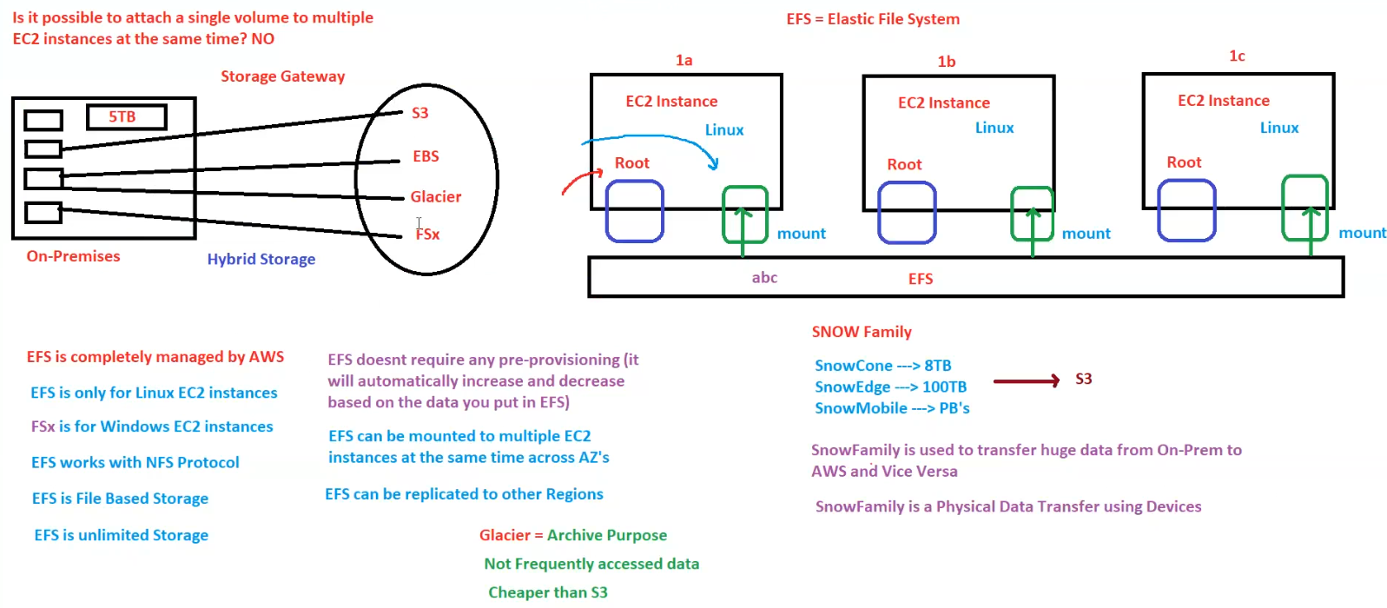

**AWS Storage Services Overview**

**1. Attaching a Single Volume to Multiple EC2 Instances**

* **Not Possible** to attach a single EBS volume to multiple EC2 instances at the same time.

**2. Hybrid Storage (On-Premises & AWS)**

* Storage Gateway enables on-premises data to connect with AWS services like:
  + **S3** (Object Storage)
  + **EBS** (Block Storage)
  + **Glacier** (Archive Storage)
  + **FSx** (Windows File System)

**3. Elastic File System (EFS)**

* **EFS = Elastic File System**
* **Fully managed** by AWS.
* **Only for Linux EC2 Instances**.
* Works with **NFS Protocol**.
* **File-based storage** solution.
* **Unlimited storage capacity**.
* **No pre-provisioning required** – it automatically scales up or down.
* **Can be mounted to multiple EC2 instances** across Availability Zones.
* **Supports replication across regions**.

**4. FSx (File System)**

* **FSx is for Windows EC2 instances**.
* **Not the same as EFS**.

**5. Glacier**

* Used for **archival storage**.
* **Not frequently accessed data**.
* **Cheaper than S3**.

**6. AWS Snow Family (Data Transfer Solutions)**

* **SnowCone** → 8TB
* **SnowEdge** → 100TB
* **SnowMobile** → Petabytes (PBs)
* Used for **large-scale data transfer** from **on-prem to AWS and vice versa**.
* **Physical data transfer** using devices.

## Database Services

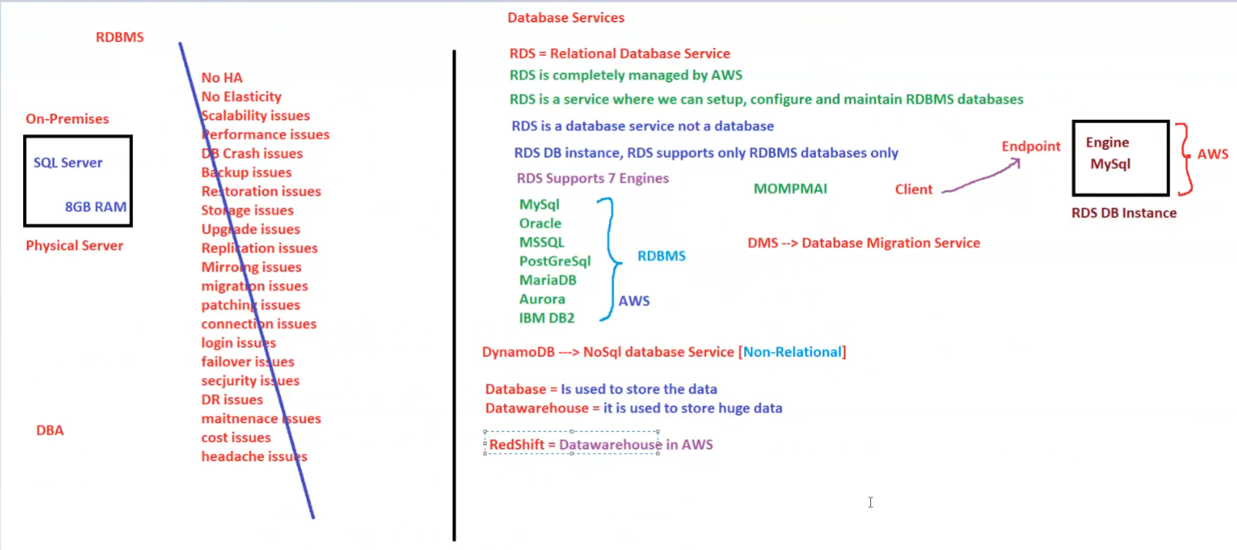

Here are the notes based on the image:

**AWS Database Services Overview**

**1. On-Premises RDBMS Challenges**

Traditional on-premises SQL Server databases face several challenges, including:

* **No high availability features** (No HA)
* **No automatic scalability**
* **Performance issues**
* **Scalability issues**
* **Database crashes**
* **Backup & restoration challenges**
* **Security risks**
* **Patching & maintenance complexities**
* **Connection and login issues**
* **Failover issues**

**2. AWS RDS (Relational Database Service)**

* **RDS (Relational Database Service)** is **completely managed by AWS**.
* Allows easy setup, configuration, and maintenance of **RDBMS databases**.
* RDS supports **7 database engines**:
  + **MySQL**
  + **PostgreSQL**
  + **MSSQL**
  + **MariaDB**
  + **Aurora (AWS native)**
  + **IBM DB2**
  + **Oracle RDS**
* **Automates**:
  + Backups
  + Software patching
  + Automatic scaling
  + High availability & failover support

**3. AWS Database Solutions**

* **DynamoDB** – NoSQL database service for high performance & scalability.
* **Amazon RDS DB Instance** (fully managed relational database in AWS).
* **DMS (Database Migration Service)** – Helps migrate databases from **on-premises to AWS**.
* **Amazon Redshift** – **AWS’s data warehousing solution**.

## AWS ElastiCache

Here are the notes based on the image:

**AWS ElastiCache - In-Memory Database Caching Service**

**1. Overview**

* **ElastiCache** is an in-memory caching service provided by AWS.
* It improves **application performance** by reducing the load on the primary database.
* Key benefits:
  + **Low latency**
  + **High performance**
  + **Faster data retrieval** for frequently accessed data.

**2. System Architecture Overview**

1. **Client (User Request)**
   * Example: User searches for "Shoes" on Flipkart.
   * Request is sent to the **Application Server**.
2. **Application Server**
   * Receives the request from the user.
   * Checks if the data is available in the **Cache Memory** before querying the **Database Server**.
3. **Cache Memory (ElastiCache)**
   * Stores **frequently accessed data**.
   * Helps reduce **database load** and improve response time.
   * Uses in-memory caching solutions like:
     + **Redis**
     + **Memcached**
4. **Database Server**
   * If data is not found in the cache, the application server queries the **database server**.
   * The database server fetches the required data from **HDD (Hard Disk Drive)** if not available in cache.
   * The response is sent back to the **application server**.
   * Frequently accessed data is stored in **cache memory** for faster retrieval in future requests.

**Key Takeaways**

* **Caching** helps reduce latency and improves performance.
* **AWS ElastiCache** supports caching with **Redis** and **Memcached**.
* Frequently accessed data is **cached to reduce direct database queries**.
* **Application Servers first check cache memory** before querying the **Database Server**.
* If data is not in cache, the database fetches it from the HDD and sends it to both the cache and the application server.
* This **reduces load on the database** and makes applications **faster & more scalable**.

## Networking Services

Here are the notes based on the image:

**AWS Networking Services Overview**

**1. Route 53 (DNS Service)**

* **Route 53 (R53) is a DNS Service from AWS**.
* Uses **DNS Port 53**.
* **Global Service** (not limited to a specific region).
* **Handles DNS records & mapping** for domain names.
* Can be used to map **user-friendly domain names** to AWS resources.
* **Example Problem:**
  + AWS ELB (Elastic Load Balancer) generates a **long and complex URL** like:  
    http://myelb.8457876.ap-south-1.elb.amazonaws.com
  + **Solution:** Use **Route 53** to map this to a custom domain, making it user-friendly.

**2. Virtual Private Cloud (VPC)**

* **VPC = Virtual Private Cloud**
* A **virtual datacenter on AWS**.
* **VPC is regional** (limited to a single AWS region).
* Each AWS region has a **default VPC**.
* **VPC contains:**
  + **Availability Zones (AZ)**
  + **EC2 instances**
  + **Subnets**
  + **Security Groups**
  + **Internet Gateways (IGW)**

**3. Connectivity Between On-Premises and AWS**

**VPN (Virtual Private Network)**

* Uses a **shared internet connection**.
* **Cheaper but less reliable** than Direct Connect.

**AWS Direct Connect**

* **Dedicated lease line** from AWS to the on-premises data center.
* **More stable & secure** than VPN.
* **Cost:** Around **$16,000** for a dedicated connection.

**Key Takeaways**

* **Route 53** helps in mapping domain names to AWS resources.
* **VPCs are regional** and act as virtual datacenters.
* **Direct Connect is a better alternative to VPN** for stable, high-speed connections between on-prem and AWS.

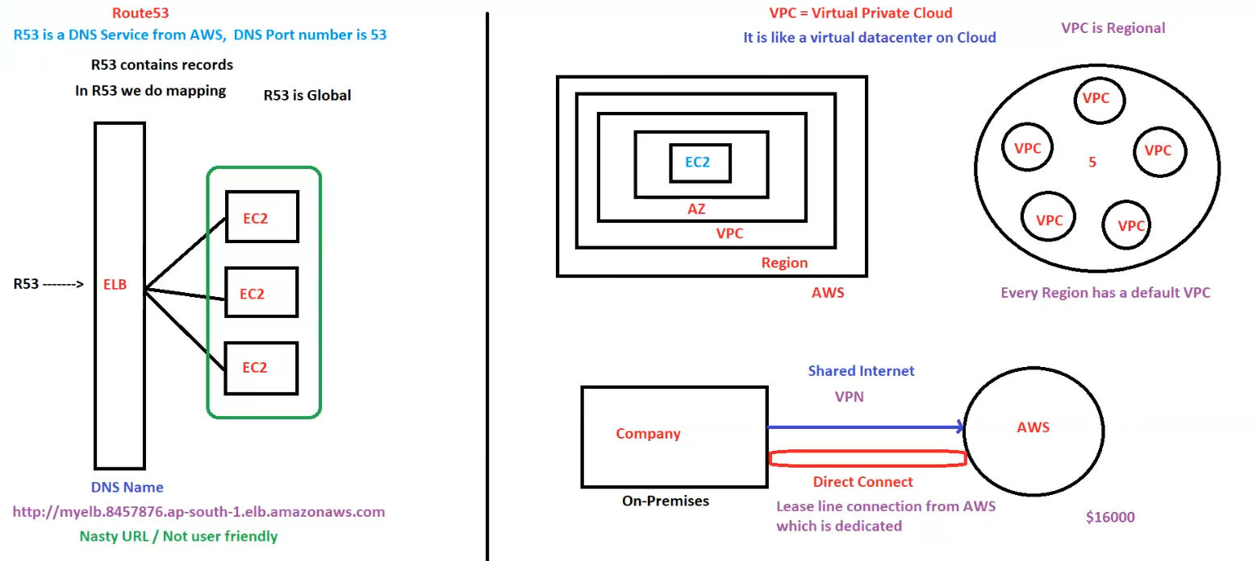

## CloudFront

Here are the notes based on the image:

**AWS CloudFront & Route 53 Overview**

**1. AWS Route 53 (DNS Service)**

* **Route 53 (R53) is AWS's DNS service**.
* **Port number**: 53 (standard DNS port).
* **Global service** (not restricted to a specific region).
* **Contains DNS records & does domain mapping**.
* Can be used to route traffic to AWS resources like **Elastic Load Balancer (ELB)** and **EC2 instances**.

**2. AWS CloudFront (CDN - Content Delivery Network)**

* **CloudFront is a CDN (Content Delivery Network) from AWS**.
* **Reduces latency & improves performance** by caching content at AWS **Edge Locations**.
* **Edge Locations (ELs)**:
  + Act as caching servers.
  + Store **static and dynamic data** close to users.
  + Managed by **AWS**.
* **TTL (Time to Live)**:
  + Determines how long data is cached before it is refreshed.
  + Example: **TTL = 12 hours** (after this, cache is updated).
* **Cache Invalidation**:
  + Deletes old cache before TTL expires.
  + Useful when content updates need immediate effect.

**3. Without vs. With CloudFront**

* **Without CloudFront → High Latency**
  + User → boom.com → Route 53 → ELB → EC2
  + Every request goes to the origin server.
* **With CloudFront → Low Latency**
  + User → boom.com → Route 53 → CloudFront (Edge Location) → ELB → EC2
  + Frequently accessed data is served from the nearest **Edge Location (EL)** instead of hitting the origin server.

**4. CloudFront Distribution Setup**

* **Create Distribution**:
  + **Define Origin** (e.g., EC2 instance).
  + **Specify Regions** (e.g., North America, Europe, Asia).
  + **Use all Edge Locations**.
  + **Create CloudFront Distribution**.

**Key Takeaways**

* **Route 53** is AWS's **global** DNS service.
* **CloudFront (CDN)** helps reduce **latency & improves performance**.
* **Edge Locations cache data** for faster delivery.
* **TTL determines caching duration** (default: 12 hours).
* **CloudFront should be used for both static & dynamic content**.

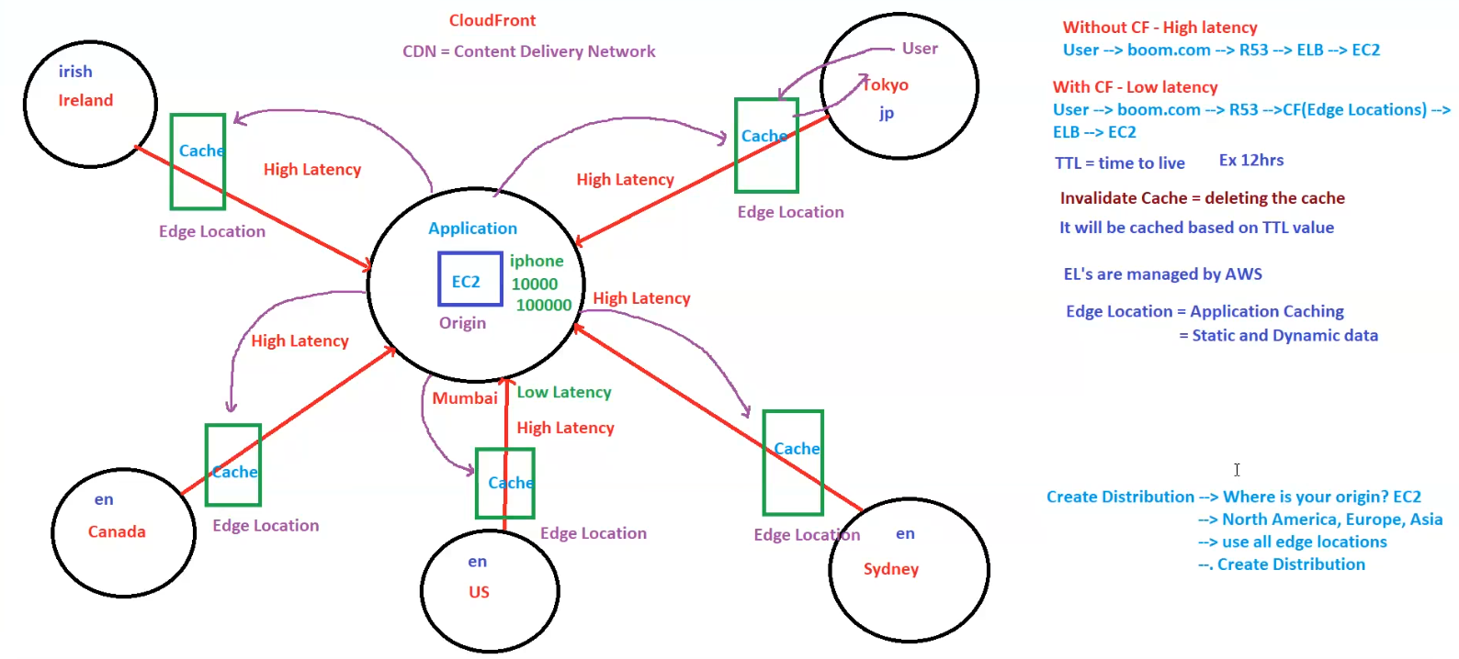

## AWS Monitoring, Security, and Support Overview

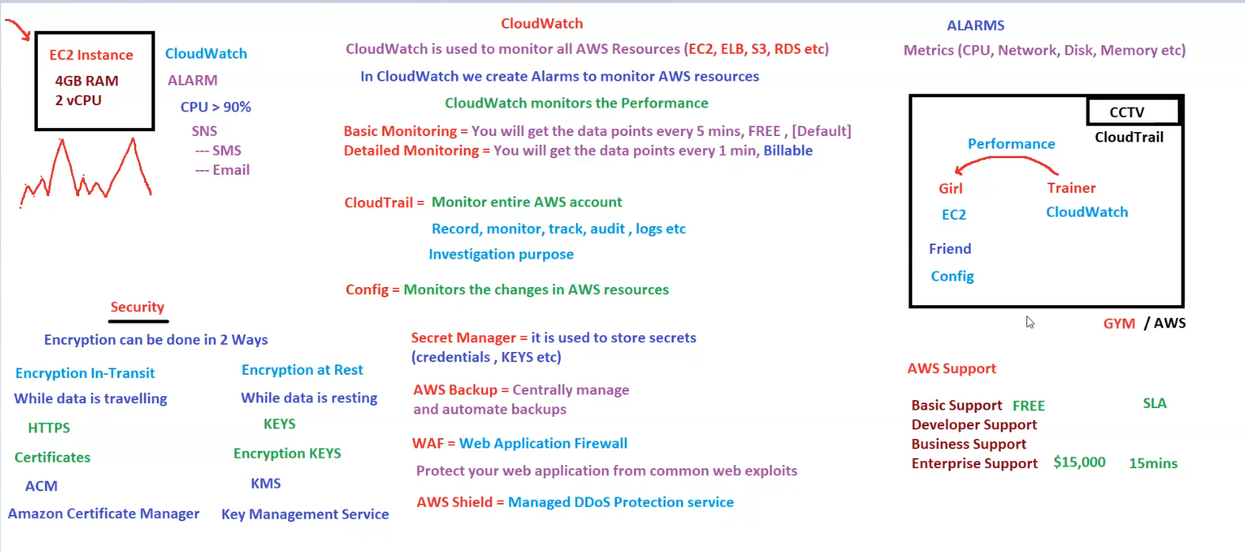

**AWS Monitoring, Security, and Support Overview**

**1. AWS CloudWatch (Performance Monitoring)**

* **CloudWatch is used to monitor AWS resources** (e.g., EC2, ELB, S3, RDS).
* **Creates alarms** to monitor resource metrics (CPU, memory, disk, network, etc.).
* **Monitors performance** in two modes:
  + **Basic Monitoring** (Free) – Data every **5 minutes** (default).
  + **Detailed Monitoring** (Billable) – Data every **1 minute**.
* **Alarms can trigger actions** via **SNS (Simple Notification Service)**:
  + Sends notifications via **SMS or Email**.

**2. AWS CloudTrail (Audit & Logging)**

* **Monitors the entire AWS account**.
* **Tracks, records, audits, and logs user activities**.
* Useful for **security investigation & compliance**.

**3. AWS Config (Change Monitoring)**

* **Monitors changes in AWS resources**.
* Helps track **configuration history**.

**4. AWS Security Features**

**Encryption**

* **Two types of encryption**:
  + **Encryption In-Transit** (while data is moving):
    - **Uses HTTPS, SSL certificates**.
    - Managed via **Amazon Certificate Manager (ACM)**.
  + **Encryption At Rest** (for stored data):
    - Uses **Encryption Keys (KMS - Key Management Service)**.

**Other Security Services**

* **Secrets Manager** – Securely stores credentials, API keys, etc.
* **AWS Backup** – Automates backups for AWS resources.
* **WAF (Web Application Firewall)** – Protects web applications from attacks.
* **AWS Shield** – **Managed DDoS protection service**.

**5. AWS Support Plans**

* **Basic Support** – **Free**.
* **Developer Support** – Paid.
* **Business Support** – Paid.
* **Enterprise Support** – **$15,000**, **15-minute SLA**.

**6. Analogy: AWS as a Gym**

* **CloudWatch = Trainer** (Monitors EC2 performance).
* **CloudTrail = CCTV** (Tracks activity logs).
* **Config = Friend** (Notifies about changes in AWS resources).

**Key Takeaways**

* **CloudWatch** is used for **real-time monitoring & alerts**.
* **CloudTrail** is for **logging and auditing user activities**.
* **AWS Config** tracks changes in AWS resources.
* **AWS provides encryption, firewall protection, and backup solutions**.
* **Support plans vary from Free to Enterprise ($15,000/month)**.